Forecasting the Electric Cars Adoption in Australia

Transportation Industry

A Literature Review

Kanchita Paophonthong
ID 1850030

Kaplan Business School T3 2025
Capstone DATA6000

For Dr Indu Bala
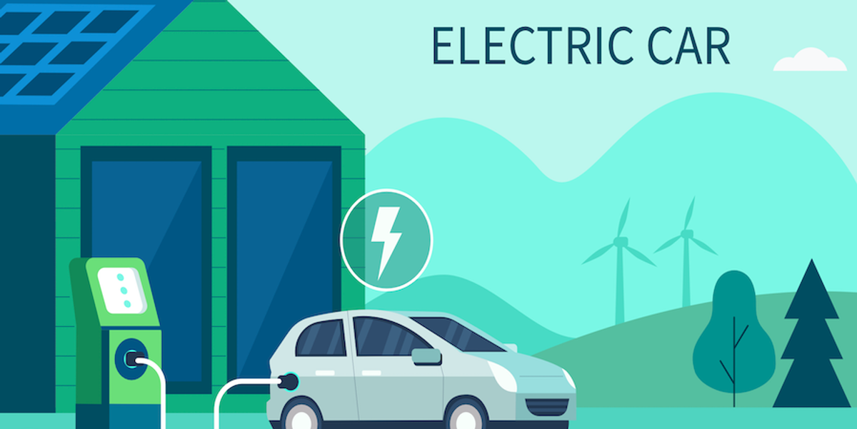

Table of Contents

The Electric Vehicle Industry ………………………………………………………………3
Challenges in the EV industry in Australia………………………………………………..8
Electric Vehicle car sales grow slow in Australia…………………………………8
High costs and limited vehicle choice restricting market accessibility………..11
Lack of government policy consistency and incentives………………………..12
Existing Analysis and Methodologies…………………………………………………….13
Data Source………………………………………………………………………………...13
Selecting a Business Problem……………………………………………………………14
The Proposed Approach…………………………………………………………..14
Data Source………………………………………………………………………...14
References………………………………………………………………………………….15

Executive Summary
Global Electric Vehicle adoption is rising, driven by climate concerns and technological improvements as Australia continues to lag behind major markets such as China, Europe and US. In 2024. This report examines key challenges affecting growth of Australia’s electric vehicle industry and identifies business problems that can be addressed through data analytics.
The Australian EVs industry has suffered from:
- Slow growth of electric vehicle sales due to inadequate charging station
- High costs and limited vehicle choice restricting market accessibility
- Lack of government policy consistency and incentives
To better understand these challenges, this study will applies geospatial analysis, clustering technique and predictive modelling to uncover patterns in charging availability, demographics, and historical adoption rates.

The Electric Vehicle Industry
In 2024, global Electric Vehicle sales reached to high number of all new car sales as transportation industry is changing rapidly as car manufacturers shift from traditional petrol and diesel vehicles to EVs due to environmental concerns, government policies, and new technology. However, EVs market in Australia remains slower than some other countries caused delays cuts in transport emissions, which are a major source of greenhouse gases globally.

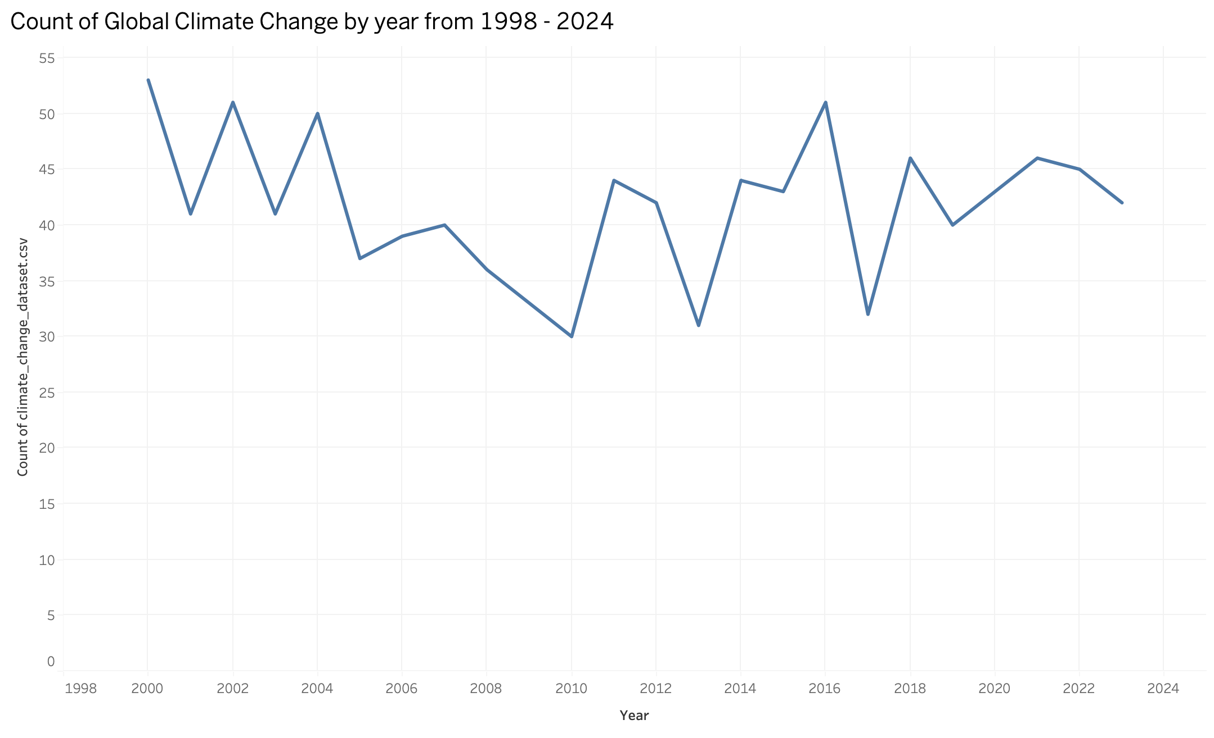

Figure 1.0 : Global climate change by year from 1998-2024
Shows that global climate indicators trend upward from 1998 to 2024, meaning the planet is getting warmer and climate impacts are intensifying over time.

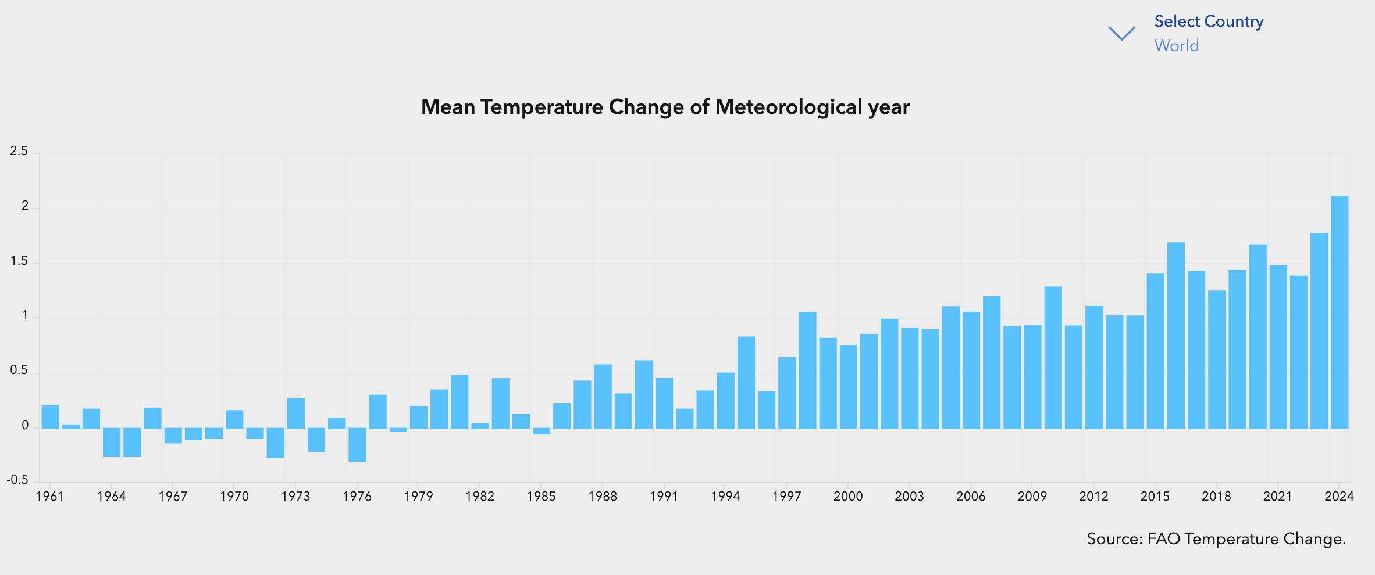

Figure 2.0: Global Annual Surface Temperature Change by year 1998-2024 (Source: MIF., 2025)
Shows global annual surface temperature change also rising over those years whether clearly warmer than the earlier year
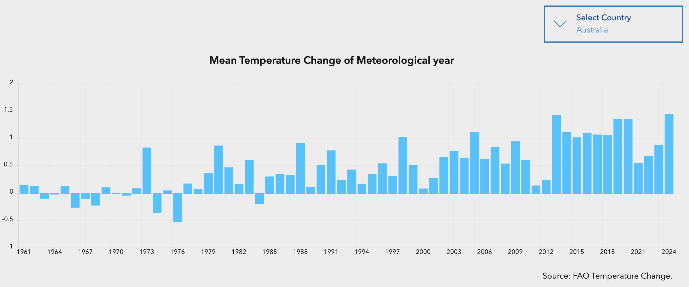
Figure 3.0: Australia Annual Surface Temperature Change by year 1998-2024 (Source: MIF., 2025) shows Australia’s annual surface temperature change following a similar upward trend, so Australia is warming along with the rest of the world.

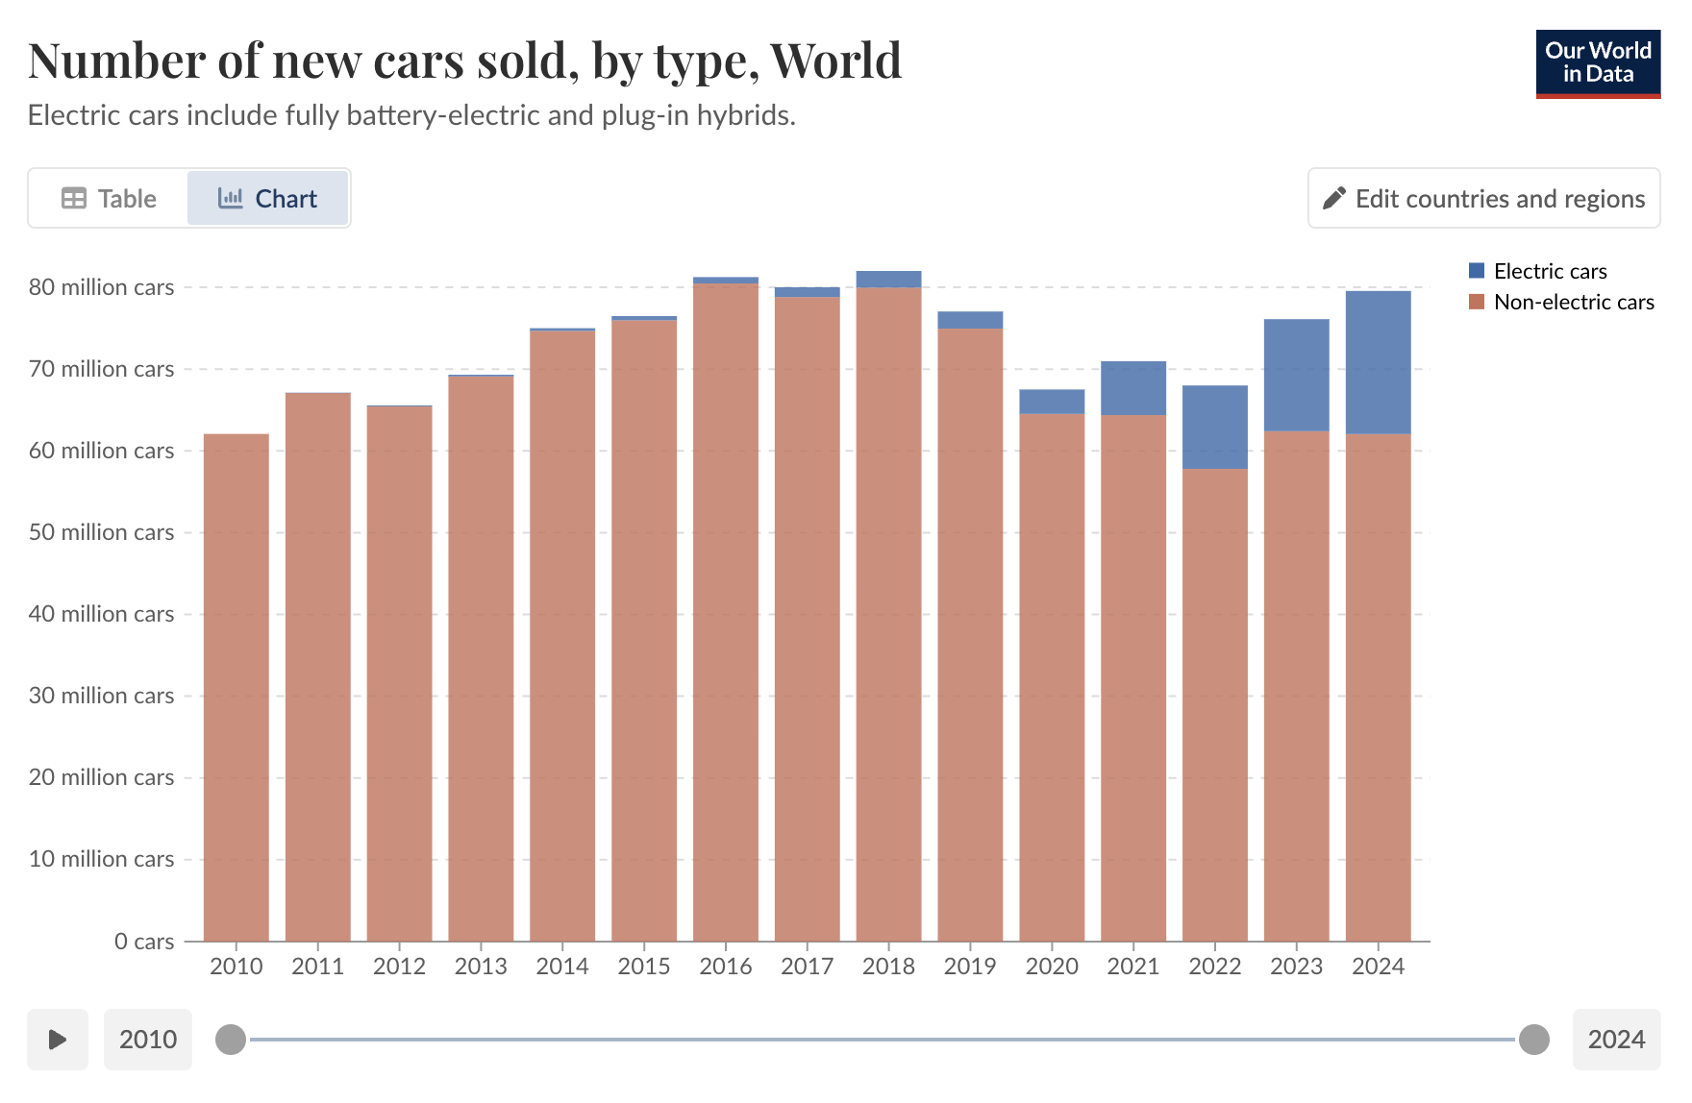
Figure 4.0: World Ev sold vs Non-EV car 2010-2024 (Source: International Energy Agency. Global EV Outlook .,2025) shows globally EV sales have grown quickly since 2018 but non‑EV cars still account for big share, so the global transition is under way but not complete.
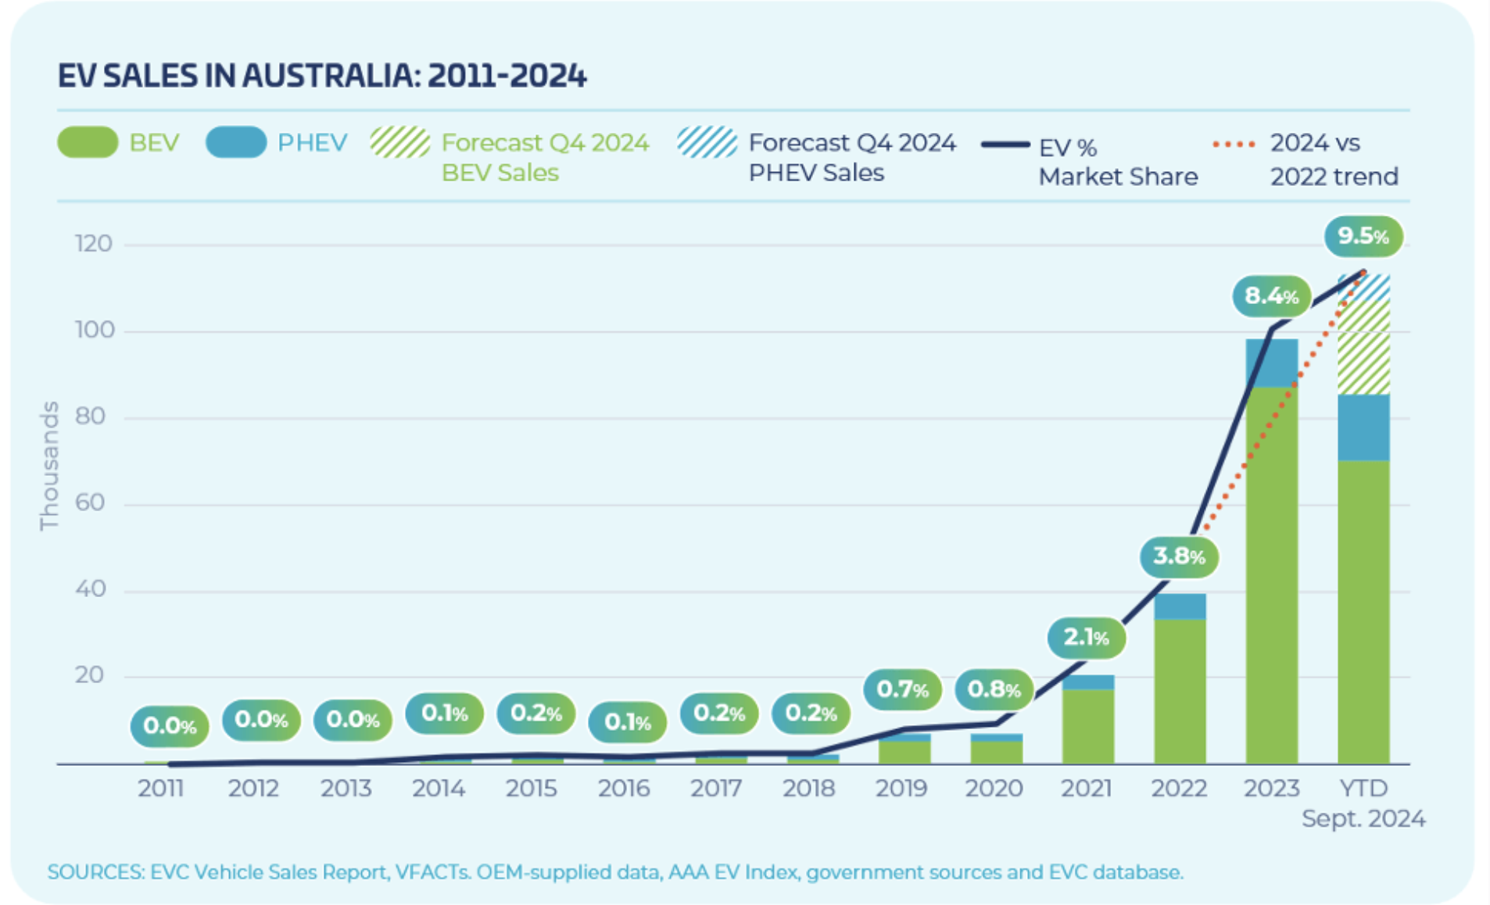
Figure 5.0: Electric Vehicle cars sale in Australia 2011-2024. (Source: State of Electric Vehicles,2024) shows EV car sales in Australia staying very low for many years, then jumping sharply in 2024, means adoption started late but is now accelerating.

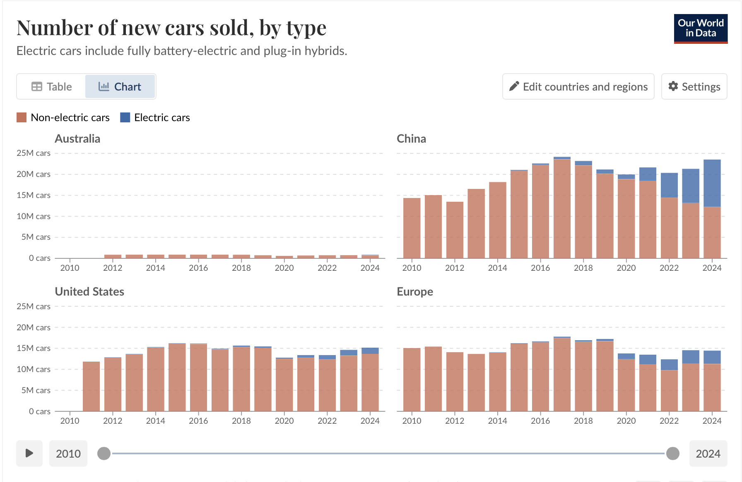 Figure 6.0: Electric Vehicle cars vs Non-Electric Vehicle cars sold in Australia,China, US and Europe by country 2010-2024 (Source: International Energy Agency. Global EV Outlook .,2025) compares EV and non-EV sales across Australia, China, the US, and Europe show that these other regions have much larger EV share than Australia, especially in 2024.

Australian Electric vehicle industry is faced with the following sets of challenges:

1. I am going to analyse why Electric vehicle car sales grow slow in Australia
2. I will classify high cost and limited choice of Electric vehicle car
3. I will develop the lack of Government policy consistency and incentives

Challenges in the EV industry in Australia

- I am going to analyse why Electric Vehicle car sales grow slow in Australia, even in big city as Sydney,NSW is slower than in China, US, Europe because there are not enough charging stations especially outside big cities. This lack of infrastructure makes buyers worry about running out of charge, so they delay switching to EVs and businesses hold back on further investment and market stuck.
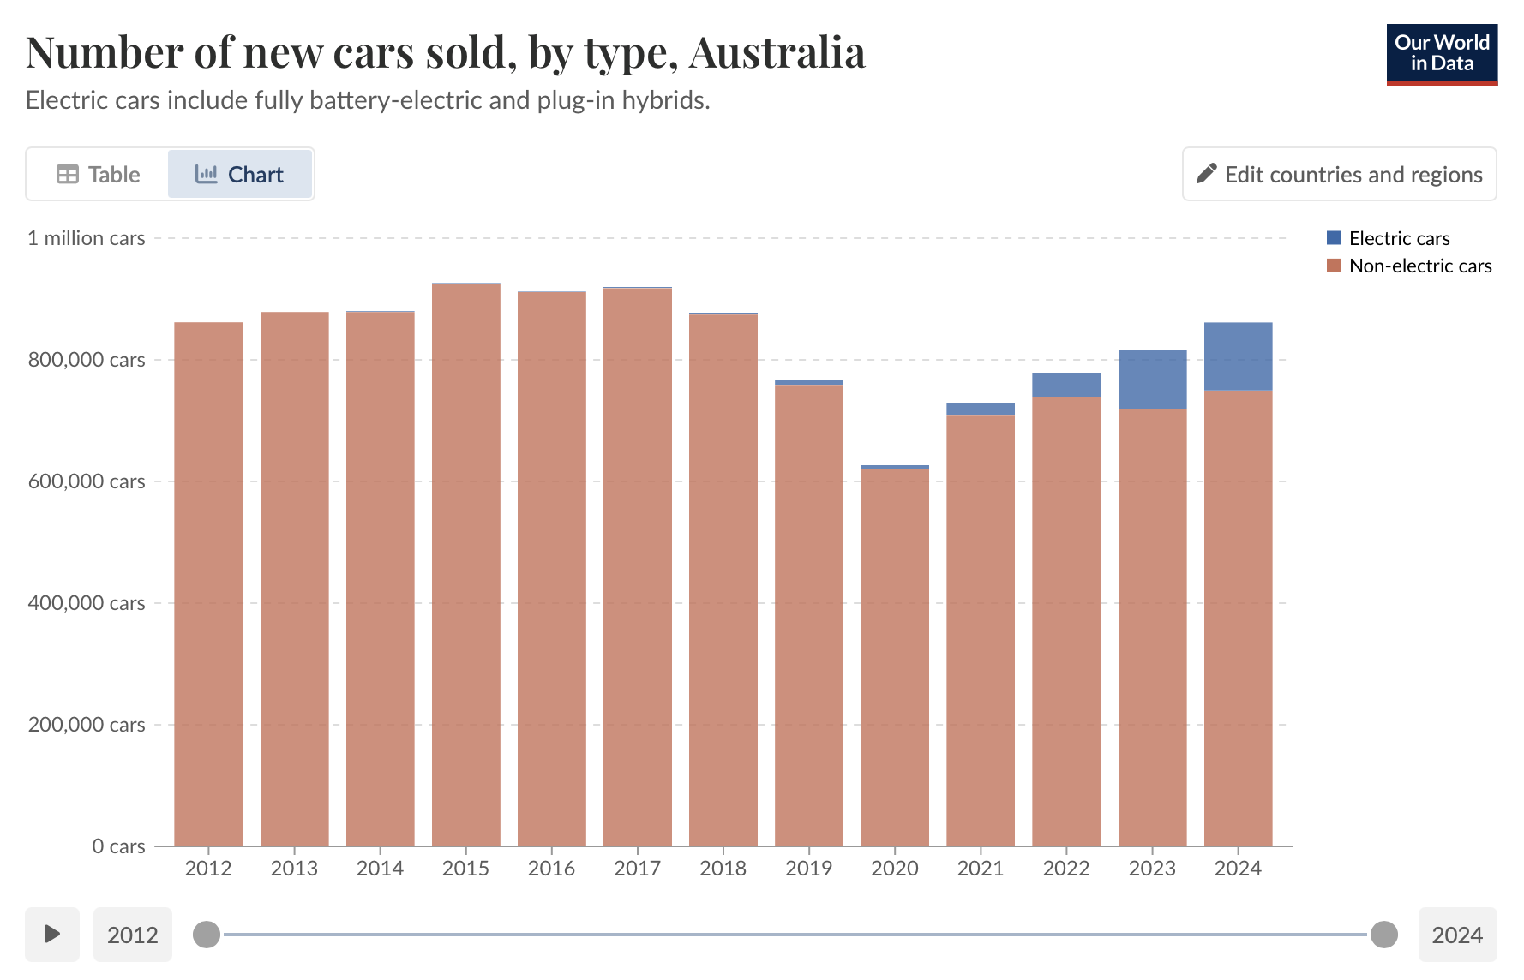
Figure 7.0: Electric Vehicle cars vs Non-Electric Vehicle cars sold in Australia 2010-2024 (Source: Source: International Energy Agency. Global EV Outlook .,2025)

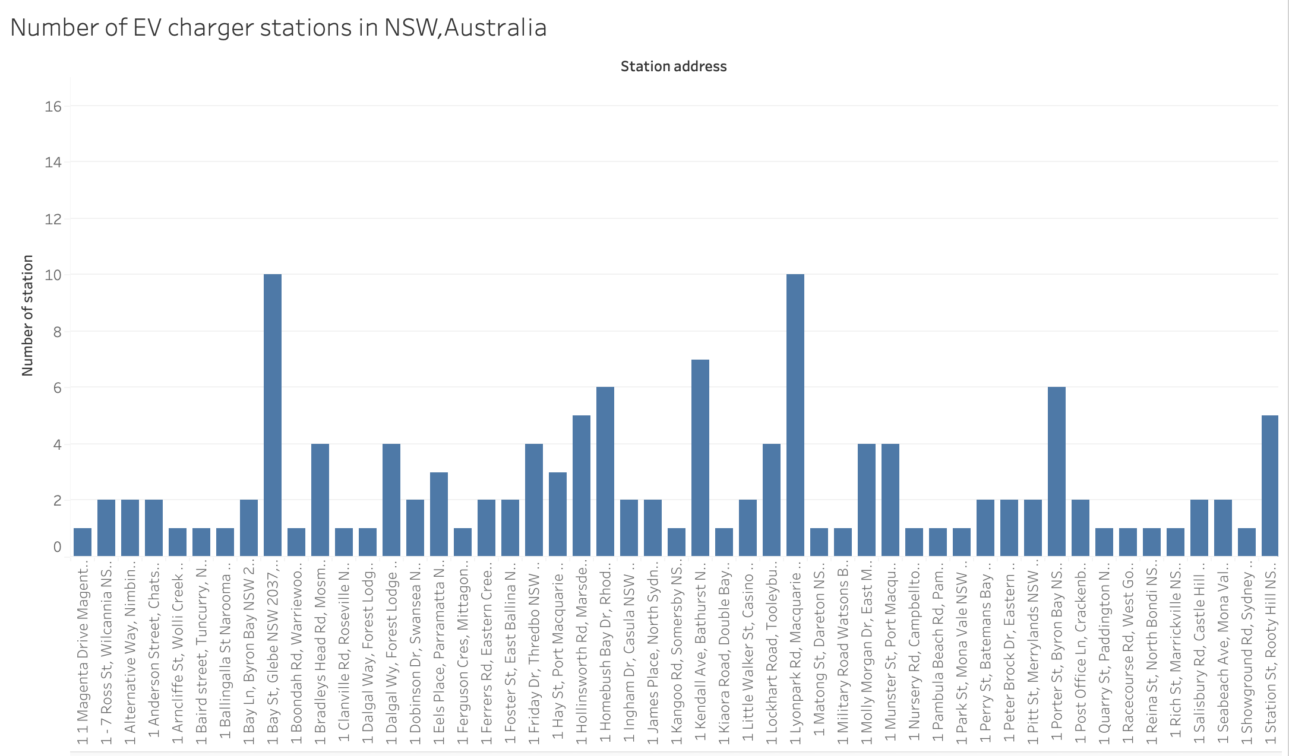

Figure 8.0: Number of top 10 EV charger stations in NSW, Australia

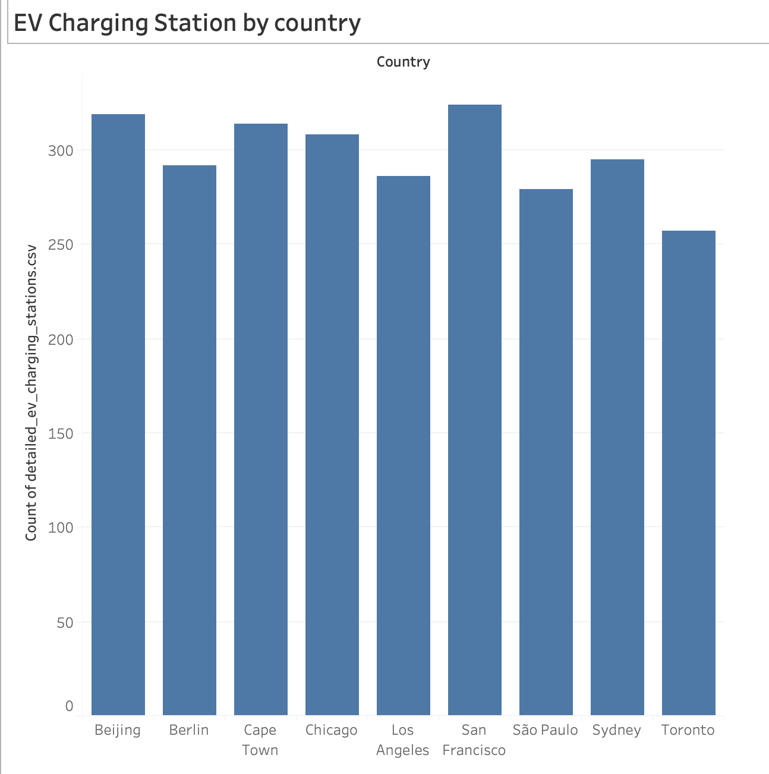
Figure 9.0: Number EV charger stations compare to other countries to Australia

- I will cluster high cost and limited choice car Electric Vehicle cars
Electric cars in Australia are still more expensive than petrol cars, so many people cannot afford them and dealers find it hard to grow sales. Higher prices and limited model options mean buyers often cannot find an EV that fits their needs or budget, which slows overall market growth.

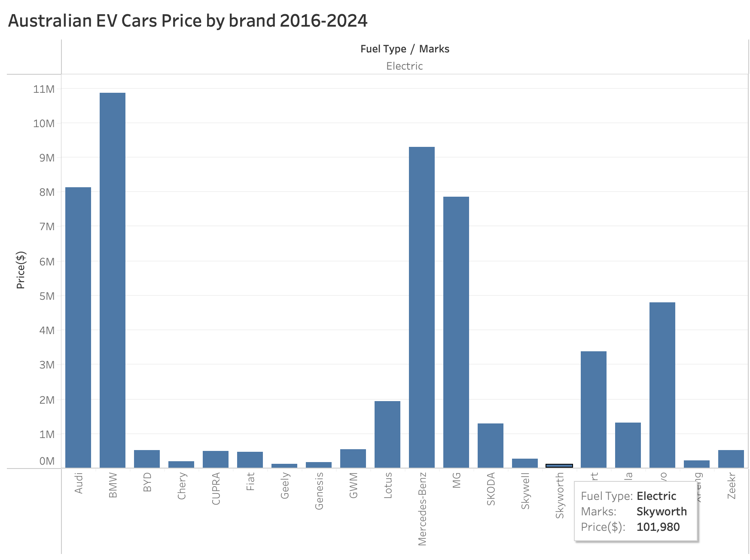

Figure 10: Australian EV cars price by brand from 2016-2024

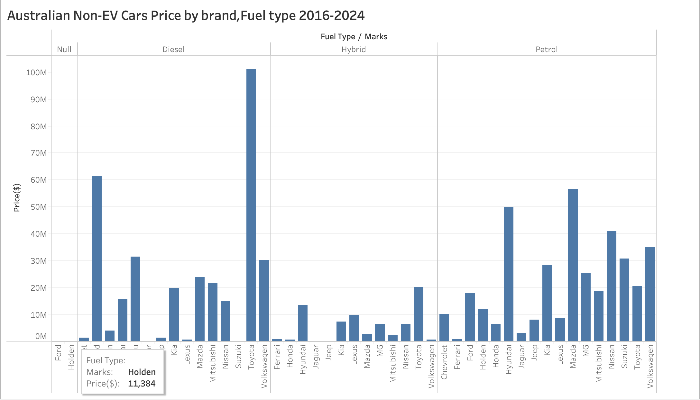

Figure 11: Australian Non-EV cars price by brand from 2016-2024

- I will evaluate the lack of Government policy consistency and incentives
Australia’s EV policies are all over the place, and that slows everything down. Each state has its own rebates and rules, so no one is really sure what support will be there in a few years.​

Existing Analysis and Methodologies

- The infrastructure study uses mapping and networking tools to show the locations of chargers and the distance drivers need to travel to reach them. And how does charger density relate to EV deployment in high-density markets, so these approaches need to be adapted to Australia's long-distance and sparse terrain. Methods include GIS spatial analysis, k-means clustering, Pearson correlation, multiple regression for the relationship between infrastructure and sales and network analysis for accessibility calculations.

- Pricing research at cost of ownership, EV price trends and drivers like battery costs and import taxes, but rarely links price to income and model availability.
Techniques include t-tests and ANOVA for price comparisons, regression models for price determinants, market segmentation analysis, logistic regression to model consumer choices and TCO calculators that include depreciation, fuel, and maintenance costs over the life of the ownership.

- Policy studies compare Australian incentives with other regions, but primarily describe current settings rather than predict how specific policy changes will affect future EV adoption It is analysed using a policy database that records incentive levels by jurisdiction and year, and vehicle registration data by state.

Data Sources:

- https://ourworldindata.org/grapher/car-sales?country=~AUS
- https://data.gov.au/data/dataset/find-a-charging-station-electric-vehicle/resource/a34d4b5f-8e3c-4995-8950-2e84fd7bb4d5
- https://www.kaggle.com/datasets/vivekattri/global-ev-charging-stations-dataset
- https://www.kaggle.com/datasets/misganawtboltana/australian-cars-for-sale
- https://www.aaa.asn.au/research-data/electric-vehicle/

Data sources provide on EV sales trends, EV chargers in NSW and globally, and vehicle pricing data essential to managing the relationship between infrastructure and adoption.

Selecting a Business Problem
I am focusing on why Electric Vehicle car sales grow slow in Australia due to lack of charging stations and which regions represent the highest-potential targets for infrastructure investment?
The Proposed Approach
1.Plot all charging stations to find average distance to nearest charger
2. Group areas by infrastructure level and EV potential. Find places with few chargers but high potential
3. Correlation and regression analysis to quantify the relationship between charging availability and historical sales growth
4. Benchmark against China, US or Europe what ratios work? How did they distribute chargers?

Data Source:
Using the data sources as highlighted in the Data Sources provided above.

References

MIF., 2025., Climate Change Data., https://climatedata.imf.org/pages/climatechange-data

MIF., 2025., Annual Surface Temperature Change., https://climatedata.imf.org/datasets/4063314923d74187be9596f10d034914/explore

Bhadra Mohit., 2024., Climate Change Dataset., https://www.kaggle.com/datasets/bhadramohit/climate-change-dataset/data

Brian Risk., Global EV Charging Stations Dataset., https://www.kaggle.com/datasets/vivekattri/global-ev-charging-stations-dataset

Our World in Data., 2025., Number of new cars sold, by type., https://ourworldindata.org/grapher/car-sales?country=~AUS

Australian Government., 2025., Find a charging station – Electric vehicle.,
https://data.gov.au/data/dataset/find-a-charging-station-electric-vehicle/resource/a34d4b5f-8e3c-4995-8950-2e84fd7bb4d5

Fleet EV News Team., February 5, 2025., EV Sales Stall: What’s Holding Australia Back?., https://fleetevnews.com.au/ev-sales-stall-whats-holding-australia-back/

Electric Vehicle Council., 2025., Electric Vehicles Available., https://electricvehiclecouncil.com.au/evs-available/

Boltana MT., 2025., Car price in Australia., https://www.kaggle.com/datasets/misganawtboltana/australian-cars-for-sale

Australian Automobile Association., 2025., Electric Vehicle Index., https://www.aaa.asn.au/research-data/electric-vehicle/

NSW Government., 2025., Electric vehicles., https://www.energy.nsw.gov.au/business-and-industry/programs-grants-and-schemes/electric-vehicles

Decrypted analytes Explaining by graph
Why we chose the problem

Then forecast

